Font to use throughout the article (including figures, where applicable): Times New Roman

Paper Title with Capitalized Initial Letters (12 points)
(two single line spacing, 12 points)

Name Surname* (11 points - single line spacing)
Department of …
University of …
E-mail: …
(one single line spacing, 11 points)
Name Surname*
Department of …
University of …
E-mail: …
(one single line spacing, 11 points)
* Corresponding author (Times New Roman, 11 points)
(three single line spacing, 11 points)

Abstract (11 points)
(one single line spacing, 11 points)
Text, 10 points, single-spaced. (min 200 - max 500 words)
(two single line spacing, 10 points)

Keywords – Keyword; Keyword; Keyword; Keyword. (10 points - max 6 words)
(one single line spacing, 10 points)
Paper type – Academic Research Paper or Practical Paper or Literature Review or whatever (10 points)
(two single line spacing, 10 points)

Sommario (Times New Roman, 11 points)
(one single line spacing, 11 points)
Article title in italics. – Times New Roman text, 10 points, single-spaced. (all in Italian)
(three single line spacing, 10 points)

Article history: (10 points - single line spacing)
Received …
Received in revised form …
Accepted …
Available online
DOI link …

(page break)

1 Paragraph title (11 points)

(one 1.5 line spacing, 11 points)
Text, 10 points, 1.5 line spacing - 0.5 cm first line indent - Text, 10 points, 1.5 line spacing - 0.5 cm first line indent.
Text, 10 points, 1.5 line spacing - 0.5 cm first line indent. Text, 10 points, 1.5 line spacing - 0.5 cm first line indent.

(two 1.5 line spacing, 10 points)

2 Paragraph title (11 points)

(one 1.5 line spacing, 11 points)
Text, 10 points, 1.5 line spacing - 0.5 cm first line indent - Text, 10 points, 1.5 line spacing - 0.5 cm first line indent.

(one 1.5 line spacing, 10 points)

2.1 Subparagraph title in bold italics (10 points)
Text, 10 points, 1.5 line spacing - 0.5 cm first line indent - Text, 10 points, 1.5 line spacing - 0.5 cm first line indent.

(one 1.5 line spacing, 10 points)
2.1.1 Title of the second subparagraph in light italics, 0.5 cm indent (10 points)
Text, 10 points, 1.5 line spacing - 0.5 cm first line indent - Text, 10 points, 1.5 line spacing - 0.5 cm first line indent.

(one 1.5 line spacing, 10 points)
Table 1 – Table title (10 points, even in the content)
(one single line spacing, 10 points)
Subjects Research Area | Frequency | % (N=360)
Business & Economics | 39 | 10.80
Business & Ethics | 62 | 17.17
Business & Management | 6 | 1.66
(one single line spacing, 9 points)
Source: … (9 points in light italics)

(one 1.5 line spacing, 10 points)

Text, 10 points, 1.5 line spacing - 0.5 cm first line indent - Text, 10 points, 1.5 line spacing - 0.5 cm first line indent.

(one 1.5 line spacing, 10 points)
Figure 1 – Figure title (10 points)
(one single line spacing, 10 points)
Phase 1  - Kotler's consumer decision model  - Motivation theories (health, sensory)  - Determinants from organic food literature  - China specific consumer behavior | Phase 2  - Identified gap:  - lack of integrated studies on Chinese olive oil market  - Research questions:  - what factors influence purchasing?  - what is their relative importance?

(one single line spacing, 9 points)
Source: (9 points in light italics)

(one 1.5 line spacing, 10 points)
Text, 10 points, 1.5 line spacing - 0.5 cm first line indent - Text, 10 points, 1.5 line spacing - 0.5 cm first line indent.

(one 1.5 line spacing, 10 points)
Figure 2 – Figure title
(one single line spacing, 10 points)
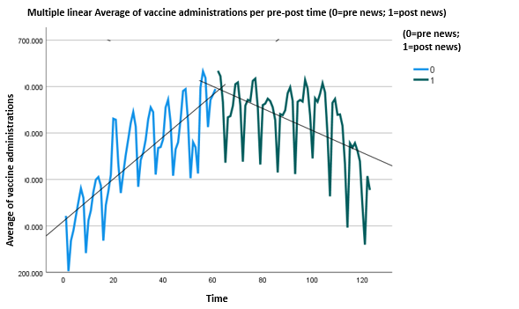
(one single line spacing, 9 points)
Source: …

(one 1.5 line spacing, 10 points)
Text, 10 points, 1.5 line spacing - 0.5 cm first line indent - Text, 10 points, 1.5 line spacing - 0.5 cm first line indent.
Text, 10 points, 1.5 line spacing - 0.5 cm first line indent - Text, 10 points, 1.5 line spacing - 0.5 cm first line indent.

(three 1.5 line spacing, 10 points)

References (11 points)
(one single line spacing, 11 points)
Baumgartner, R. J., & Ebner, D. (2010). Corporate sustainability strategies: sustainability profiles and maturity levels. Sustainable Development, 18(2), 76-89.
Becker, C. (2011). Sustainability ethics and sustainability research. Springer.
Ortolano, A., & Angelini, E. (2021). Green Bonds Capital Returns: The Impact of Market and Macroeconomic Variables. In M. La Torre & H. Chiappini (Eds.), Contemporary Issues in Sustainable Finance (pp. 91-116). Palgrave.
(bibliographic citations 10 points, single line spacing, 6 points apart, 0.5 cm hanging indent)

Text, 9 points, single-spaced. Text, 9 points, single-spaced. Text, 9 points, single-spaced. Text, 9 points, single-spaced. Text, 9 points, single-spaced.

